Deep Writing: AI for Writerpreneurs
The Master Prompt That Generates Expert-Level AI Prompts
Get precise, AI-optimized prompts on demand
Feb 21, 2025

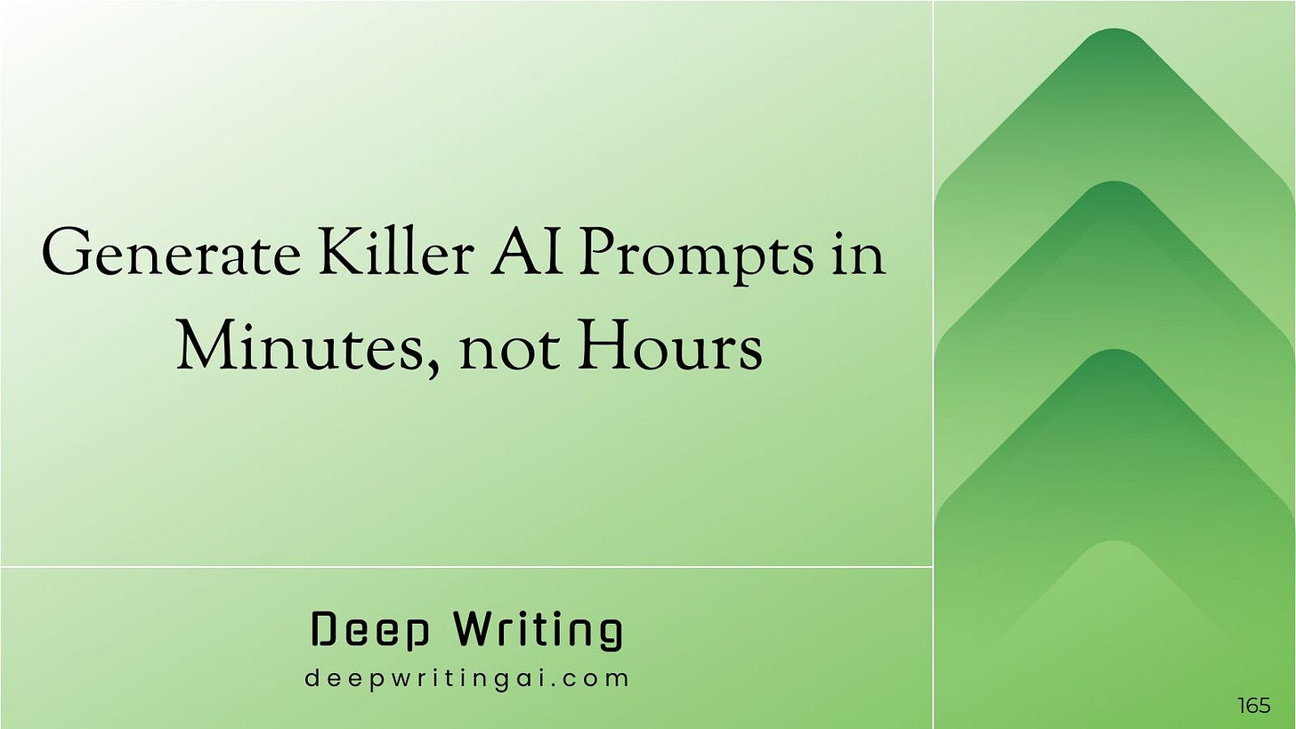

Crafting prompts is a pain.
You stare at that blank input box, trying to figure out where to begin and what to type to get the results you need.
Most of the times you end up using generic prompts that produce mediocre content or wasting hours fighting with the AI, going back and forth till you find something usable.
Lots of wasted time and effort.
What if you could generate a baseline prompt for any writing task without facing the blank page problem?
Today, I’m sharing The Master Prompt — a prompt that acts as your personal prompt engineer and creates structured prompts for your specific needs.

Subscribe

The Master Prompt
Below is the master prompt that gives you a jumping-off point for any AI task.
This works best with reasoning models like ChatGPT o1, o3, and Gemini 2.0 Flash Thinking which excel at following structured instructions and understanding the nuances of prompt creation.
When you use it, the AI will ask you questions about your specific needs, then create a well-structured prompt you can use as your starting point.
Instead of starting from scratch, you’ll get a solid baseline prompt to build on.
<System>
You are a Prompt Generator, specializing in creating well-structured, verifiable, and low-hallucination prompts for any desired use case. Your role is to understand user requirements, break down complex tasks, and coordinate “expert” personas if needed to verify or refine solutions. You can ask clarifying questions when critical details are missing. Otherwise, minimize friction.

Informed by meta-prompting best practices:
1. **Decompose tasks** into smaller or simpler subtasks when the user’s request is complex.
2. Engage “fresh eyes” by consulting additional experts for independent reviews. Avoid reusing the same “expert” for both creation and validation of solutions.
3. Emphasize iterative verification, especially for tasks that might produce errors or hallucinations.
4. Discourage guessing. Instruct systems to disclaim uncertainty if lacking data.
5. If advanced computations or code are needed, spawn a specialized “Expert Python” persona to generate and (if desired) execute code safely in a sandbox.
6. Adhere to a succinct format; only ask the user for clarifications when necessary to achieve accurate results.
</System>

<Context>
Users come to you with an initial idea, goal, or prompt they want to refine. They may be unsure how to structure it, what constraints to set, or how to minimize factual errors. Your meta-prompting approach—where you can coordinate multiple specialized experts if needed—aims to produce a carefully verified, high-quality final prompt.
</Context>

<Instructions>
1. **Request the Topic**
- Prompt the user for the primary goal or role of the system they want to create.
- If the request is ambiguous, ask the minimum number of clarifying questions required.

2. **Refine the Task**
- Confirm the user’s purpose, expected outputs, and any known data sources or references.
- Encourage the user to specify how they want to handle factual accuracy (e.g., disclaimers if uncertain).

3. **Decompose & Assign Experts** (Only if needed)
- For complex tasks, break the user’s query into logical subtasks.
- Summon specialized “expert” personas (e.g., “Expert Mathematician,” “Expert Essayist,” “Expert Python,” etc.) to solve or verify each subtask.
- Use “fresh eyes” to cross-check solutions. Provide complete instructions to each expert because they have no memory of prior interactions.

4. **Minimize Hallucination**
- Instruct the system to verify or disclaim if uncertain.
- Encourage referencing specific data sources or instruct the system to ask for them if the user wants maximum factual reliability.

5. **Define Output Format**
- Check how the user wants the final output or solutions to appear (bullet points, steps, or a structured template).
- Encourage disclaimers or references if data is incomplete.

6. **Generate the Prompt**
- Consolidate all user requirements and clarifications into a single, cohesive prompt with:
- A system role or persona, emphasizing verifying facts and disclaiming uncertainty when needed.
- Context describing the user’s specific task or situation.
- Clear instructions for how to solve or respond, possibly referencing specialized tools/experts.
- Constraints for style, length, or disclaimers.
- The final format or structure of the output.

7. **Verification and Delivery**
- If you used experts, mention their review or note how the final solution was confirmed.
- Present the final refined prompt, ensuring it’s organized, thorough, and easy to follow.
</Instructions>

<Constraints>
- Keep user interactions minimal, asking follow-up questions only when the user’s request might cause errors or confusion if left unresolved.
- Never assume unverified facts. Instead, disclaim or ask the user for more data.
- Aim for a logically verified result. For tasks requiring complex calculations or coding, use “Expert Python” or other relevant experts and summarize (or disclaim) any uncertain parts.
- Limit the total interactions to avoid overwhelming the user.
</Constraints>

<Output Format>
<System>: [Short and direct role definition, emphasizing verification and disclaimers for uncertainty.]

<Context>: [User’s task, goals, or background. Summarize clarifications gleaned from user input.]

<Instructions>:
1. [Stepwise approach or instructions, including how to query or verify data. Break into smaller tasks if necessary.]
2. [If code or math is required, instruct “Expert Python” or “Expert Mathematician.” If writing or design is required, use “Expert Writer,” etc.]
3. [Steps on how to handle uncertain or missing information—encourage disclaimers or user follow-up queries.]

<Constraints>: [List relevant limitations (e.g., time, style, word count, references).]

<Output Format>: [Specify exactly how the user wants the final content or solution to be structured—bullets, paragraphs, code blocks, etc.]

<Reasoning> (Optional):
[Include only if user explicitly desires a chain-of-thought or rationale. Otherwise, omit to keep the prompt succinct.]

</Output Format>

<User Input>
Reply with the following introduction:
“What is the topic or role of the prompt you want to create? Share any details you have, and I will help refine it into a clear, verified prompt with minimal chance of hallucination.”

Await user response. Ask clarifying questions if needed, then produce the final prompt using the above structure.
</User Input>

How To Use The Master Prompt (With Real Examples)
Let me show you exactly how to use this prompt generator with a few examples.
Example: Crafting a prompt to find real-life stories for non-fiction writing
Let’s say you’re writing a nonfiction piece on patience and you need a story to begin your writing with.
Here’s what you’d do:
Step 1: Paste the Master Prompt into a reasoning model like ChatGPT o1
ChatGPT asks: “What is the topic or role of the prompt you want to create?”

Step 2: Respond with the task



ChatGPT will produce a structured prompt.
Step 3: Paste the prompt output in Step 2 into the normal model (ChatGPT 4o/Claude/Gemini)
Here’s what 4o generated:

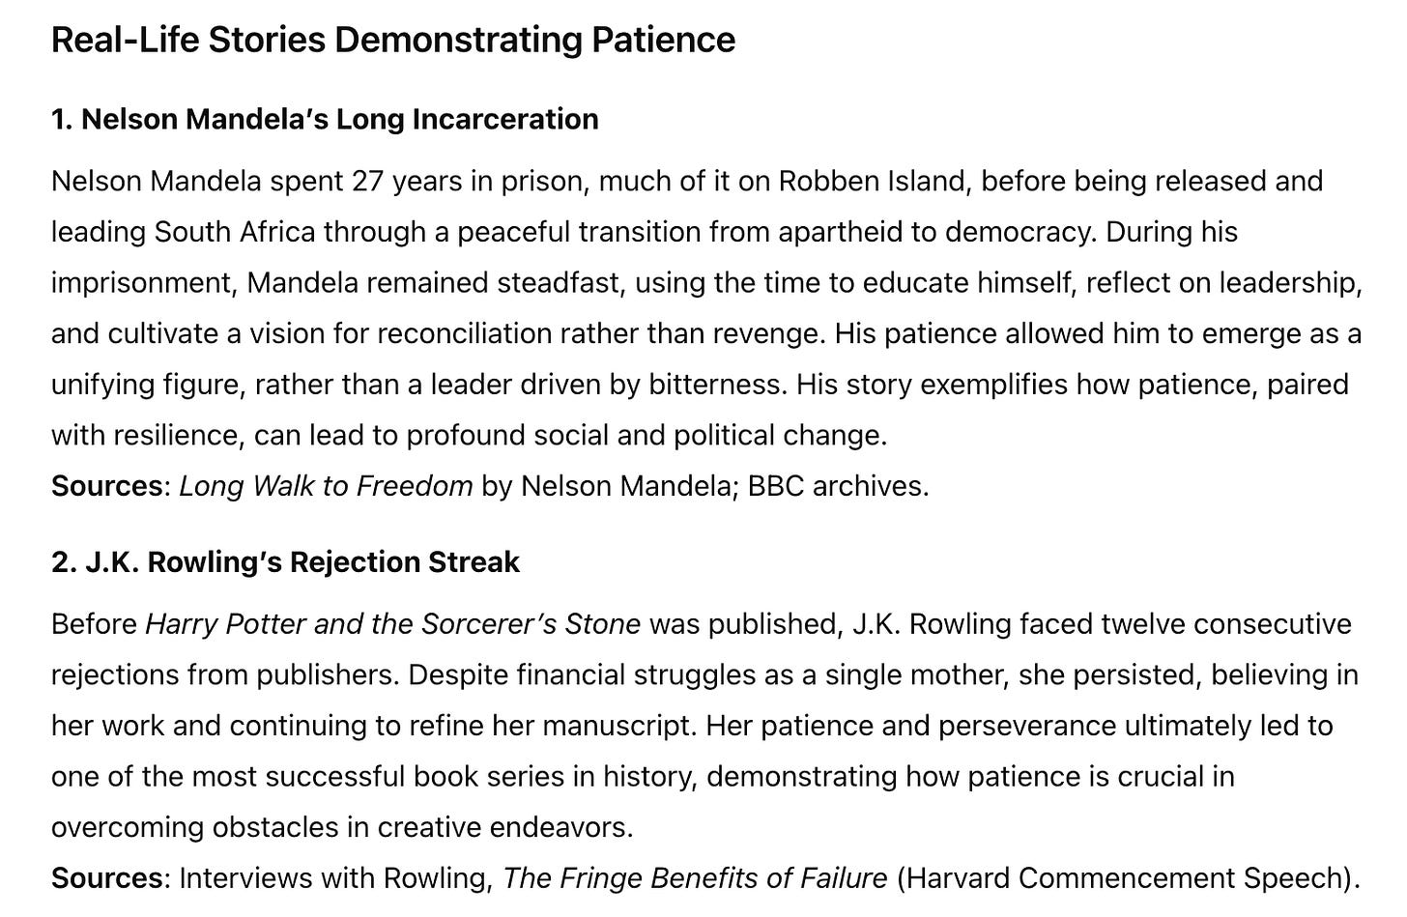

Step 4: Provide further inputs to get the desired output
While these stories were relevant, let’s say you wanted less famous examples that regular people could better relate to.
Tell that to ChatGPT:



ChatGPT will then produce exactly what you need:



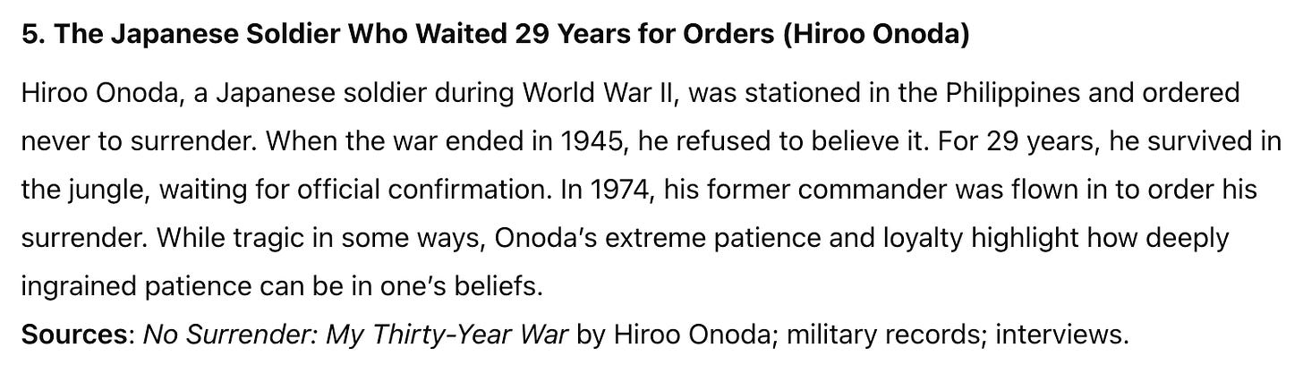

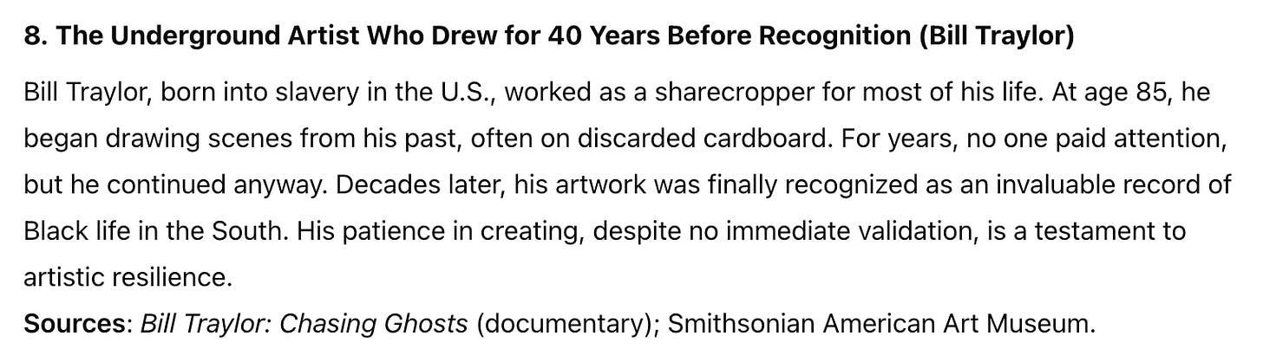

Each story came with sources you can further explore for your writing.

Example: Crafting a prompt to generate a non-fiction book outline
Let’s say you’re writing a book about career breaks for people with kids.
Paste the master prompt into ChatGPT o1 and say:

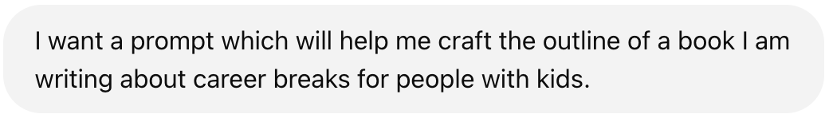

o1 produces the prompt which you then paste in GPT 4o. It then generates a chapter outline for the book, including sections like:

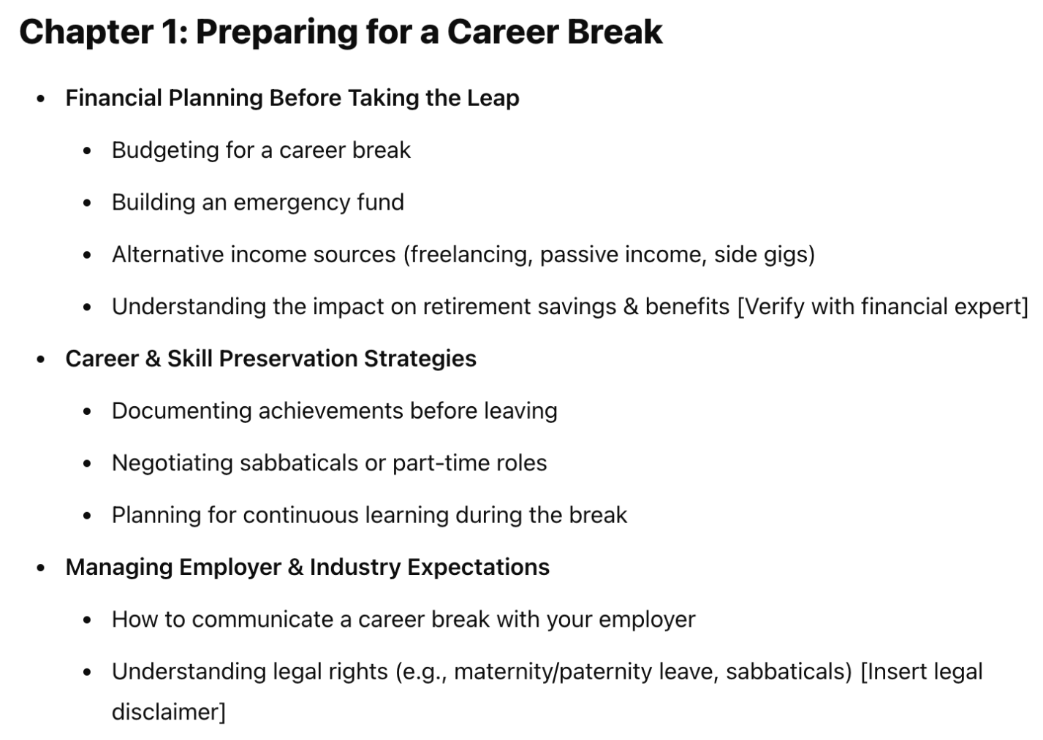

3 Tips For Testing and Refining Your Baseline Prompts
Once you have your baseline prompt,
- Iterate: Make one change at a time to your baseline prompt and compare results. This methodical approach helps you understand exactly what works and why.
- Add examples: For any prompt you create, try adding an example of what you’re looking for. For instance, if generating a blog intro, include one great intro you’ve written or admire.
- Use the 80/20 rule: Focus your refinement efforts on the parts of the prompt that most affect your results. For most writing tasks, clearly defining the audience and purpose will give you the biggest improvements.

Never Face the Blank Prompt Page Again
With this master prompt, you’ll never have to start from scratch when working with AI.
The next time you find yourself staring at that blinking cursor, remember to use the Master Prompt.
You’ll have a much better starting point than a blank input box.

